REPORT

CUSTOMER'S REF NO.: | PO113342
ALS THAILAND REF NO.: | ATT/ELP/15/1110-COP
DATE: | 06 August 2015
COMPANY: | Saint Gobain Performance Plastics Rencol Ltd.
DATE SAMPLE RECEIVED: | 29-July-2015
DATE ANALYZED: | 29-July-2015
DATE TEST COMPLETED: | 05-August-2015

SAMPLE DESCRIPTION: | One lot of sample was received with references:
 | Description: RING6354G
 | Model: B226252
 | Surface Area: 2.31 cm2
 | Remark: Seagate Monthly

METHOD/PROCEDURE:
Analysis | Procedure No | Number of pieces  used for extraction
Copper Wire Corrosion | 20800021-001 Rev B | 1

ALS THAILAND REF NO.: | ATT/ELP/15/1110-COP
DATE: | 06 August 2015
COMPANY: | Saint Gobain Performance Plastics Rencol Ltd.

RESULTS :
The Specification is based on Seagate's Doc 20800010-120 Rev.BG
for Mechanical Cmpts Not in Contact w Discs (non EN, non FC) to be used Directly in the cleanroom
Copper Wire Corrosion test | Specification Limits | Results 1 | Results 2 | Results 3
80oC,48hours | Corrosion on the copper wire when exposed to the test must be less than level 2 | Pass (level 0) | Pass (level 0) | Pass (level 0)
Photo Before: Photo After:
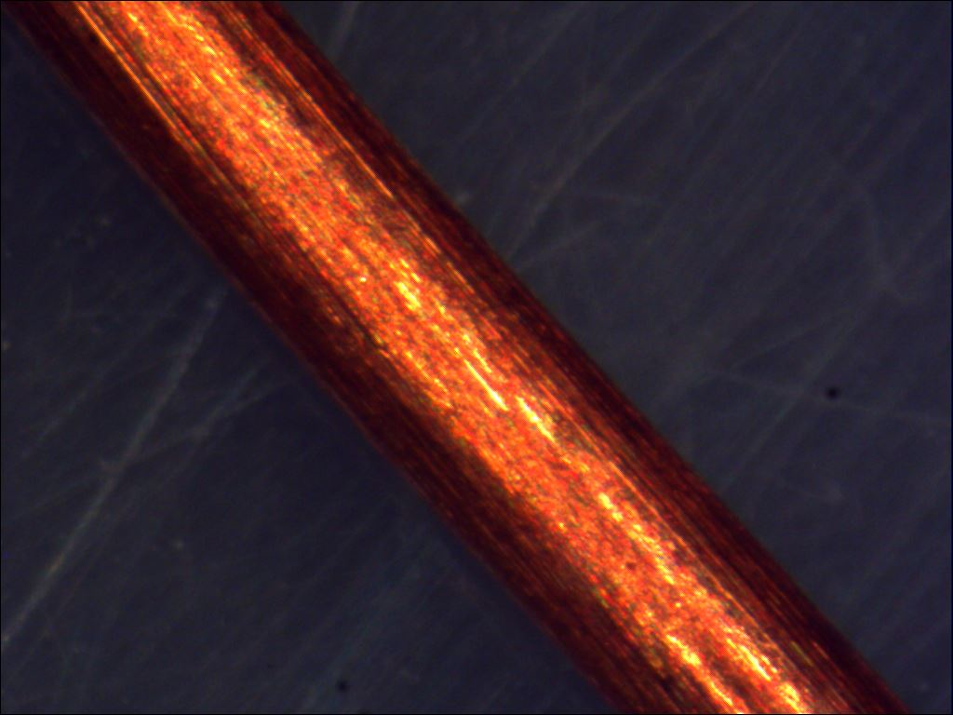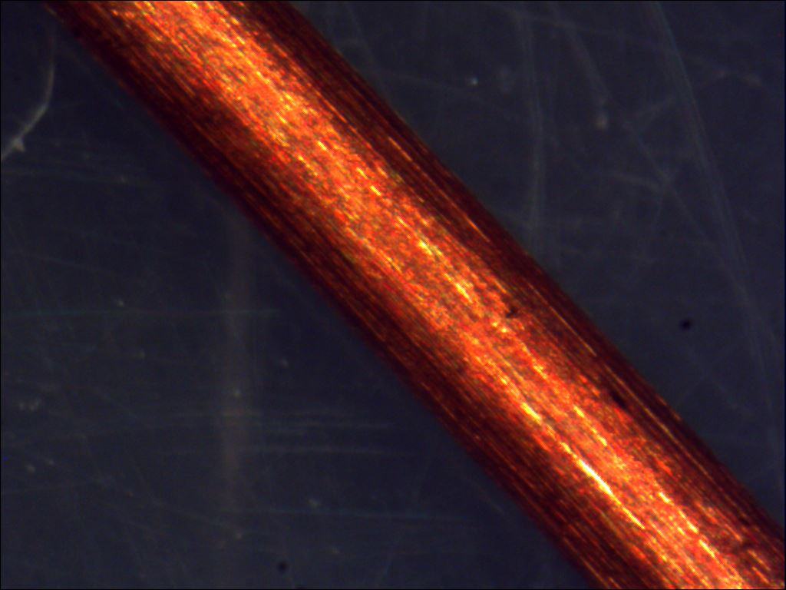

Remark:
1.) The result related only to the test items.
2.) The test report shall not be reproduced except in full, without written approval of ALS Testing Services (Thailand) Co., Ltd.

- END OF REPORT –

ALS Testing Services
(Thailand) Co.,Ltd.
-----------------------------------
Warunee Maneesuwan
M.Sc, B.Sc, Laboratory Manager

